SUCCESSFUL DIRECT MAIL CAMPAIGNS
Direct Mail That Works Includes Key Steps and Components

Example of a postcard that incorporates 9 key components
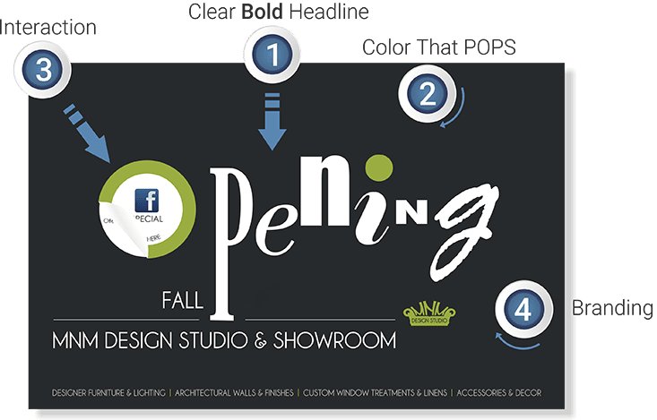

A little bit about us…
We help customers attract, serve and retain clients via the print, mail & digital mediums. For almost 60 years our clients, distributors and re-seller partners throughout North America have trusted us to produce a wide variety of marketing, mail and transactional communications.
Please drop us a line or give us a shout… info@margraphics.com or 800-851-4460

